

**INTEGRATED FAMILY PLANNING (FP) DASHBOARD**

User Manual (Draft)

**PREPARED AND SUBMITTED BY:**

PROJECT TEAM

DEPARTMENT OF COMPUTER SCIENCE AND ENGINEERING

UNIVERSITY OF DAR ES SALAAM

**FOR**

**THE REPRODUCTIVE AND CHILD HEALTH SECTION (RCHS) OF THE MINISTRY OF HEALTH, COMMUNITY DEVELOPMENT, GENDER, ELDERLY AND CHILDREN (MoHCDGEC)**

**March 2016**

|  |  |
| --- | --- |
|  |  |

Revision History

|  |  |  |  |  |
| --- | --- | --- | --- | --- |
| **Date** | **Version** | **Author** | **Section** | **Amendment** |
| March 4, 2016 | Draft 1 | UDSM | All | n/a |
| March 21, 2016 | Draft 2 | UDSM/CHAI | All |  |
| March 31, 2016 | Draft 3 | UDSM/CHAI | All |  |
|  |  |  |  |  |

Table of Contents

1 Introduction to Family Planning Dashboard 4

1.1 General Introduction 4

1.2 FP Dashboard Features in Brief 5

2 How to use the Family Planning Dashboard in HMIS Web-Portal 6

2.1 Opening the HMIS Web-Portal 6

2.2 Opening the Family Planning (FP) Dashboard 6

2.3 Menus and Navigation 7

2.3.1 Navigating the ‘top’ menu 8

2.3.1.1 Selecting period 8

2.3.1.2 Selecting geography 8

2.3.1.3 Selecting FP method 9

2.3.1.4 Updating the chart 9

2.3.2 Navigating the ‘left’ menu and chart options 9

2.3.2.1 Homepage 10

2.3.2.2 Coverage Charts 11

2.3.2.3 Client Charts 14

2.3.2.4 Stock-Outs Charts 17

2.3.2.5 Service Integration Charts 18

2.3.2.6 Report Subscription tab 20

2.4 Chart Features 21

2.4.1 View as chart or table 22

2.4.2 Download data as CSV 22

2.4.3 Print or download the chart 23

2.4.4 Get description of the chart or table 23

2.4.5 Hide and unhide data 23

2.4.6 View data label on the chart 24

2.5 PDF Reports 24

3 Appendices 24

3.1 Appendix 1: Overview of Home Page 24

3.2 Appendix 2: Overview of Client Charts 24

3.3 Appendix 3: Overview of Stock-Out Charts 24

3.4 Appendix 4: Overview of Service Integration Charts 25

Definitions and acronyms

|  |  |
| --- | --- |
| CBD | Community-Based Distribution |
| CHAI | Clinton Health Access Initiative |
| DHIS | District Health Information System |
| DoCSE | The Department of Computer Science and Engineering |
| FP | Family Planning |
| HIS | Health Information System |
| HIV | The human immunodeficiency virus |
| HMIS | Health Management Information System |
| HR | Human Resource |
| HTC | Village Agricultural Extension Officer(s) |
| HWs | Health Workers |
| ICT | Information and Communication Technology |
| MoHCDGEC | Ministry of Health, Community Development, Gender, Elderly and Children |
| PAC | Post Abortion Care |
| RCHCos | Reproductive Child Health Coordinators |
| RCHS | Reproductive and Child Health Section |
| UDSM | University of Dar es Salaam |
| URL | Universal Resource Locator |

# Introduction to Family Planning Dashboard

The Tanzania Family Planning Dashboard is a web-based tool that maps the human resource capacity at facilities to provide family planning (FP) commodities against the consumption and stock status of these commodities, in order to inform decision-making by government and partners at national and subnational levels. This document is a user manual, providing detailed instructions on how to use the Dashboard.

## General Introduction

The Tanzania eHealth Strategy (2013-2018) aims at enabling more efficient use of healthcare resources through replacing paper-intensive processes and providing better information management, supporting the improved multi-way communication and sharing of information among clinicians, patients, and caregivers within the health sectors and across partner agencies. To this end, the strategy calls for an integration and interoperability of Health Information Systems (HIS) to support more efficient access to needed data and information for policy development and delivery of health care.

In line with this, the Reproductive and Child Health Section (RCHS) of the Ministry of Health, Community Development, Gender, Elderly and Children (MoHCDGEC) is supported by Clinton Health Access Initiative (CHAI)[1] to improve Family Planning (FP) program management at the national and sub-national levels, through utilization of data to inform decision-making. Through this support, an integrated FP dashboard has been developed which allows FP program managers to utilize data, identify gaps and problems and set evidence-based targets. The aim of the FP Dashboard is to serve as Tanzania’s primary FP program and performance management tool, helping to identify gaps in HR training and FP services for more targeted and efficient program planning and resource allocation.

The Department of Computer Science and Engineering (DoCSE), University of Dar es Salaam (UDSM)[2] has worked with the MoHCDGEC to develop a web-based portal to display graphical representation of national DHIS2 data and indicators for numerous health programs. The FP dashboard is housed within this web-portal and displays ‘coverage’, ‘client’, ‘stock-outs’ and ‘service integration’ FP information using data from DHIS2 and the family planning human resource (HR) training database ‘TrainTracker’. It displays charts and automatically generates monthly summary reports which are emailed to users.

The FP dashboard, in line with the existing web-portal, is free and open access (no user log-in is required) and the charts are accessible through clicking on the family planning tab on the web-based portal. It is intended for use by all FP donors, partners, and government program managers in Tanzania and has been designed to require only limited analytical skills to use.

The development of the FP Dashboard involved a core group of stakeholders from RCHS, HMIS and ICT units within MoHCDGEC, UDSM and CHAI, who worked collaboratively to ensure that this dashboard system was developed to meet the needs of the users, using existing data without creating a parallel system.

## FP Dashboard Features in Brief

As part of its family planning project, CHAI supported RCHS to develop a free and open access family planning dashboard in the existing HMIS web-portal. Unlike the DHIS-2 access, which is restricted, the dashboard (in line with the HMIS web-portal) is publicly open and can be accessed without log-in requirements. The objective of this dashboard is to provide users with integrated charts and reports using real-time family planning service and human resources data. This is to help monitor and track performance in various strategic and operational areas while strengthening data for decision-making around FP services.

To implement the above main objective the FP dashboard includes the following features:

* Charts which display monthly service data from DHIS-2 and training data from the ‘Train Tracker’
* National, Regional and District-level PDF Reports which provide monthly summaries and suggested action points for dashboard users

Details on these FP dashboard features and instructions on how to use the FP dashboard are described in the subsequent sections of this manual.

# How to use the Family Planning Dashboard in HMIS Web-Portal

## Opening the HMIS Web-Portal

This FP Dashboard is a web-based application integrated in the HMIS Web-Portal, thus is available via an Internet browser (an application you use to access internet e.g. Internet Explorer, Mozilla Firefox, Google Chrome, Opera, etc.) when you have Internet Connection. To access the application, it is recommended to use Mozilla Firefox and Google chrome (Internet Explorer is not advised to be used, but if it is necessary use the latest version of the browser).

To access the dashboard, open your browser and type in the URL of the HMIS Web-Portal ([www.hmisportal.moh.go.tz](http://www.hmisportal.moh.go.tz)) in the address field. You will see the web-portal screen.

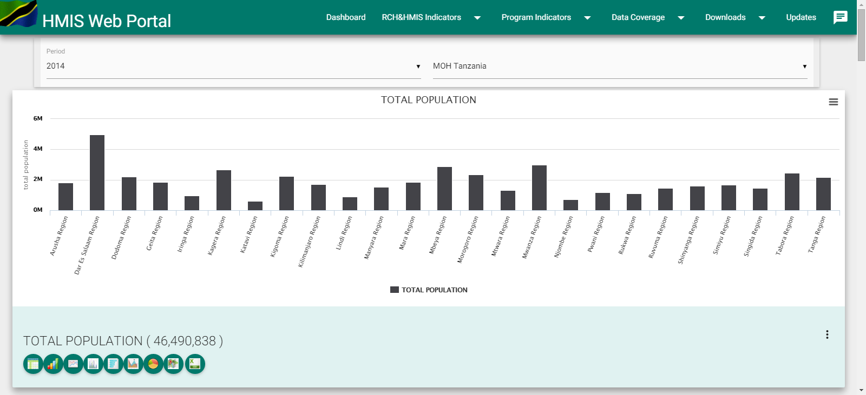

Figure 1: HMIS Web-Portal Screen

## Opening the Family Planning (FP) Dashboard

1. Once you see the HMIS Web-Portal screen, select Family Planning from the Program Indicators to access the FP Dashboard.

**Note:** You do not need a username and password to access HMIS Web-Portal or the FP Dashboard.

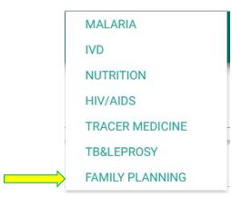

Figure 2: Select Family Planning from Program Indicators

1. Once you have successfully selected Family Planning from the Program Indicators you will see the FP Dashboard ‘Home’ page, where you can immediately view four charts showing most recent national-level data.

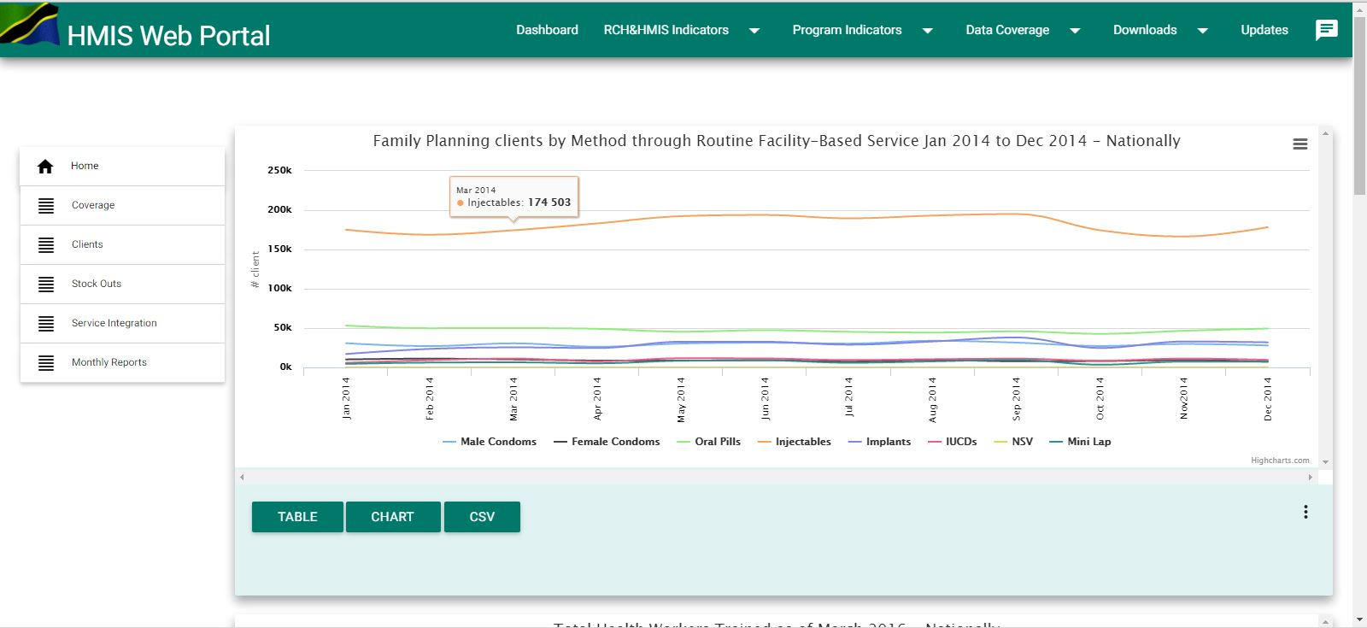

Figure 3: Family Planning ‘Home’ Page

1. You can then choose to display Coverage, Clients, Stock-Outs or Service Integration information for Family Planning, by using the menu on the left as shown in figure 4.

## Menus and Navigation

The FP Dashboard has two menu systems: The left side menu, which is the main menu that allows you to choose the type of Family Planning information you want to display: coverage, client, stock-outs or service integration..

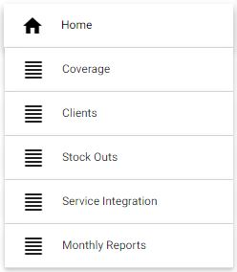

Figure 4: The Left Menu

The menu along the top of the page allows you to change the time period, geography, and FP method that you are interested in, and to update the information displayed on the chart according to your selections.

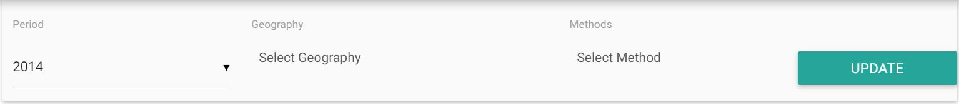

Figure 5: The top menu

### Navigating the ‘top’ menu

The information displayed for charts is for the default period of time, geography (all seven zones) and FP method (implants) but you can change these selection through navigation on the top menu as follows:

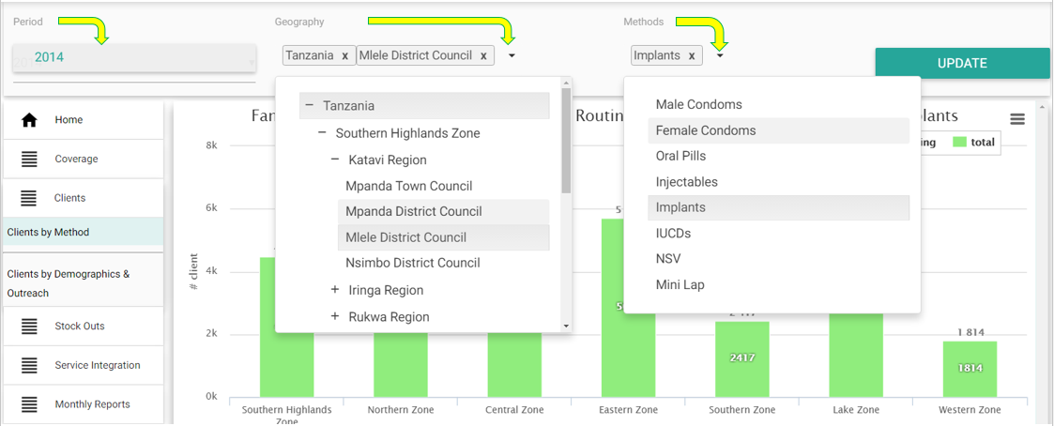

Figure 6: Selecting period, geography and FP method

#### Selecting period

* Use the top left menu to select the period you want from the list of available periods in the drop down. For example, if you want to see data from previous years, this is where you can select the time period you are interested in.

#### Selecting geography

* Use the second menu from the top left to select the geography you are interested in seeing. Depending on your information needs, there are four levels you can view:
* National-level
* Zonal-level
* Regional-level
* District-level

***Note:*** You can select any combination of geographic levels to display, such as some districts, regions, zones, and national. However, you can select up to a maximum of seven geographies only in total, regardless of the level.

* Click on the down arrow to expand the tree then click on the respective zone, region or district to select.
* Each zone, region or council is added in the list when you click on it. To remove it from the selection, click on the ‘X’ icon after the name in the list.

#### Selecting FP method

* For some of the charts, you will also need to specify the FP method you are interested in.
* Specifically, the following sub-tabs require you to select an FP method: Clients by Method, Clients by Demographics & Outreach, HWs Trained, Facilities with HWs Trained, Facilities Providing FP Over Time and Facilities with HWs Trained Providing FP
* For these charts, a third menu option appears at the top where you can select the FP method(s) you are interested in, from the drop down list.

#### Updating the chart

* Once you have selected the period, geography and-or method you are interested in, you must click on “**Update button”** (at the top right) to update the information on the chart(s) accordingly.

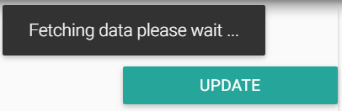

Figure 7: Updating the chart

***Note:*** Fetching of data might take sometimes but the message “Fetching data please wait …” indicates it is still working, so please wait.

Also, the system allows multiple selections for one filter limiting the selection on the other filter to one. Example, if you select multiple geographies you can only select one method and one period or if you select multiple methods you can only select one geography and one period.

### Navigating the ‘left’ menu and chart options

The left side menu is the main menu of the FP dashboard. It allows a user to choose the type of family planning information to display on the charts. At first, when you open the FP dashboard, you will be directed to the homepage where you will see four.

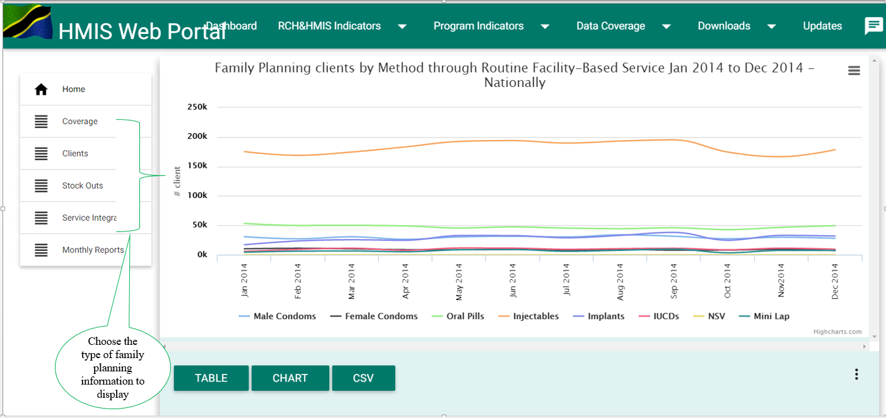

Figure 8: Selecting Left Side Menu on the FP Dashboard Home Page

Depending on your information needs, you can choose to view family planning information from any of the following categories: coverage, client, stock-outs or service integration information.

See Appendices 1-4 for description; interpretation of data; data sources; and numerator and denominators used for each indicator.

***Note:*** The data displayed after selecting a coverage, client, stock-outs or service integration chart is the default period (current year), geography (all seven zones) and FP method (implants) but you can change these through navigation on the top menu as it is explained in the respective section.

#### Homepage

* While working on other pages of the FP dashboard and you want to be directed back to the homepage click on the ‘Home’ button where you will see four charts.
* At first, when you open the FP dashboard, you will be directed to the homepage where you will see four charts. If you click on ‘Home’ button it reload the charts on the homepage.

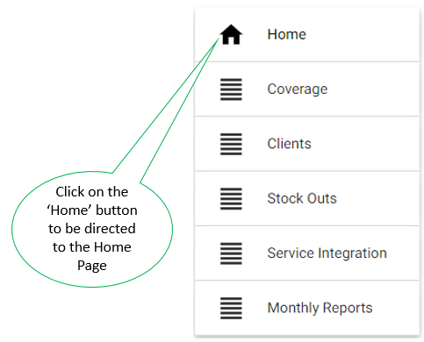

Figure 9: Selecting the ‘Home’ Button on the Left Side Menu

#### Coverage Charts

If you are interested in viewing FP service provision and human resource coverage information click on the ‘Coverage’ button and then, depending of your information need, you can select to display any of the eleven charts by clicking on the respective sub-tabs in the coverage tab menu.

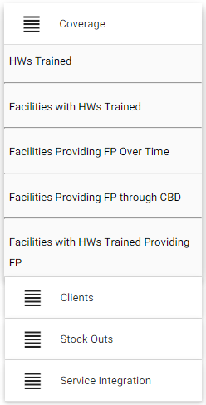

Figure 10: Selecting family planning coverage

* **HWs Trained**: This displays one chart to view absolute number of providers trained in all FP methods, in selected geographies, to date.

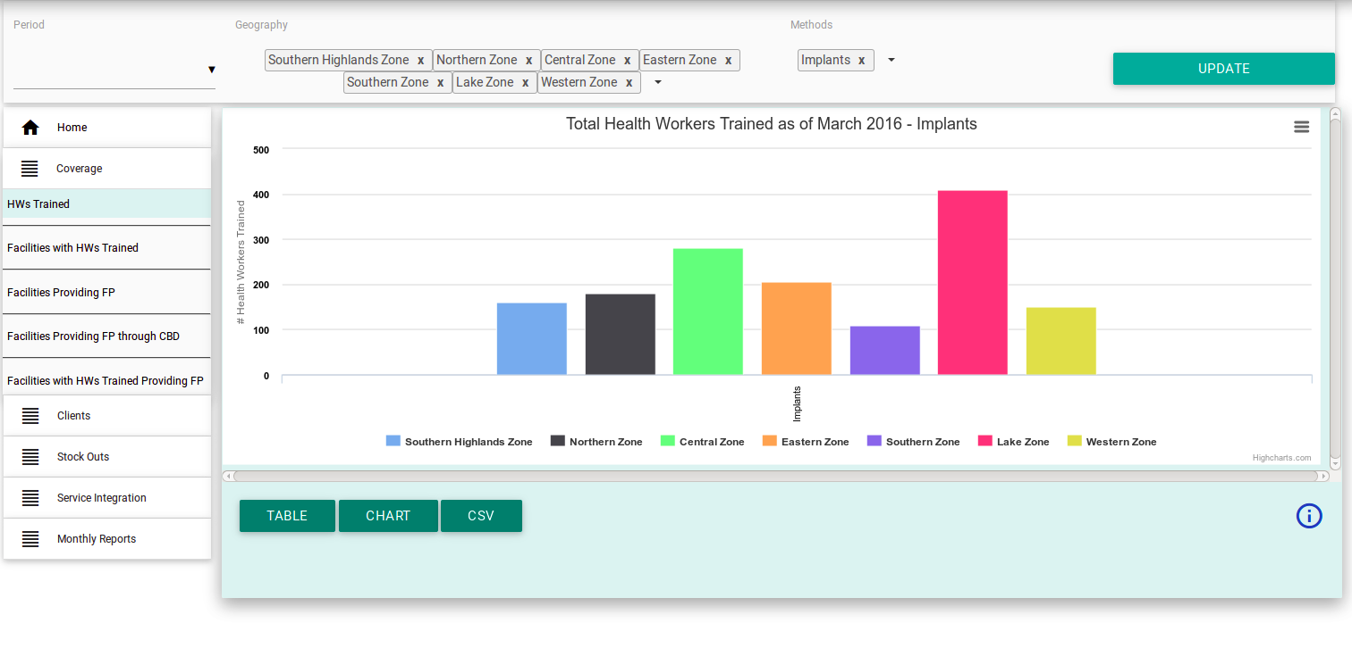

Figure 11: Selecting Health Workers Trained

* **Facilities with HWs Trained:** This displays three charts to view gaps in health providers trained at hospitals, health centers and dispensaries for the selected FP method type, in the selected geography, for the current month to date. You can scroll the page up and down to view all charts.

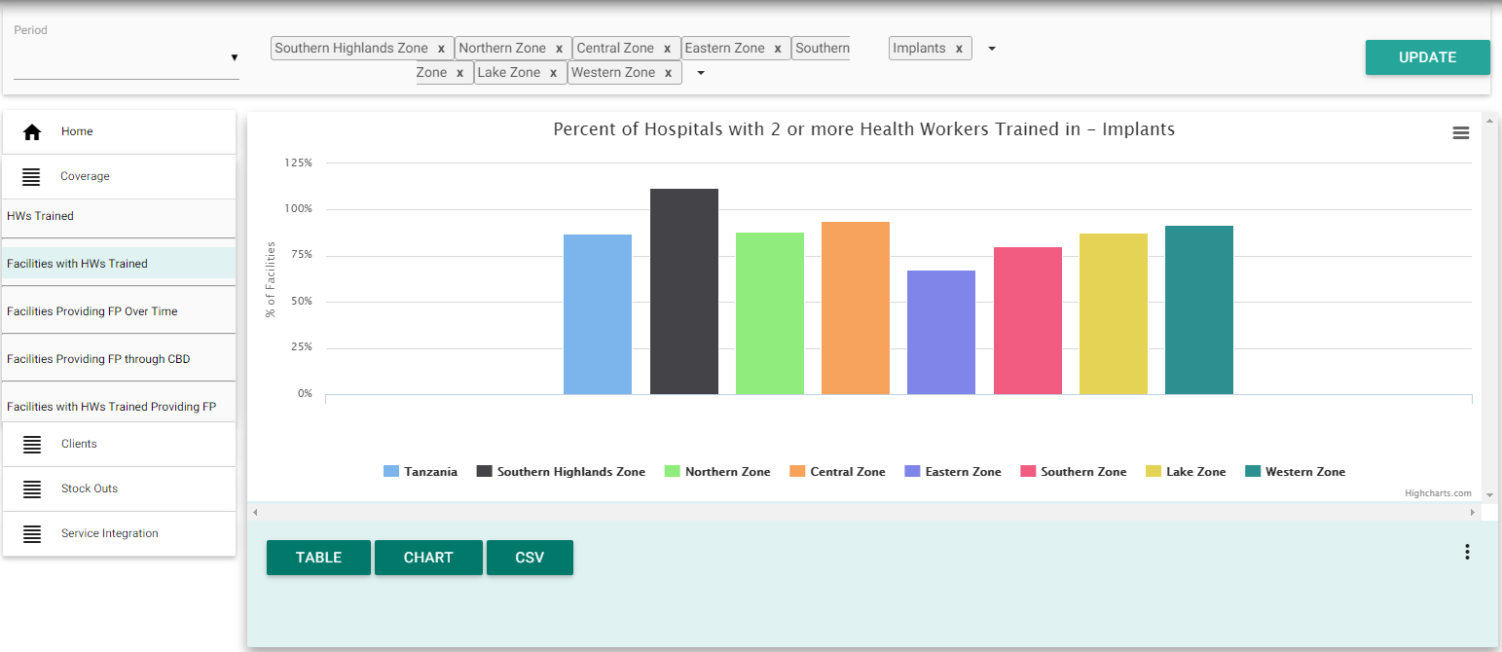

Figure 12: Selecting Facilities with HWs Trained

* **Facilities Providing FP Over Time:** This displays three charts to view percentage of hospitals, health centers and dispensaries providing each FP method by method type and geography over a 12-month period. You can scroll the page up and down to view all charts.

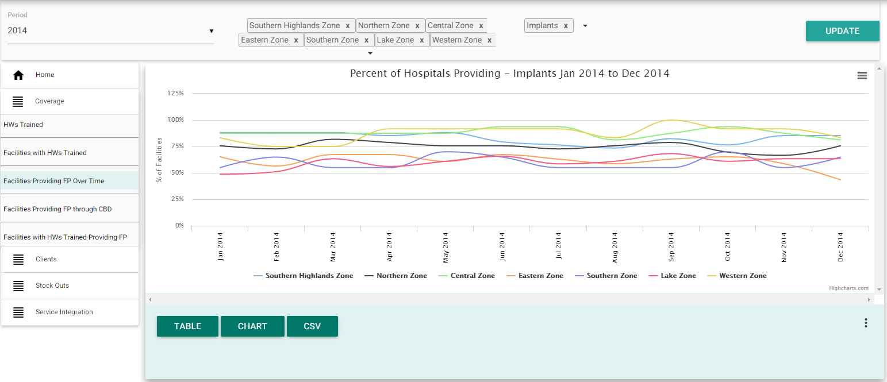

Figure 13: Selecting Facilities Providing FP Over Time

* **Facilities Providing FP through CBD**: This displays one chart to view gaps in facilities providing condoms or pills through community-based distribution (CBD) by geography, over the last 12-month period.

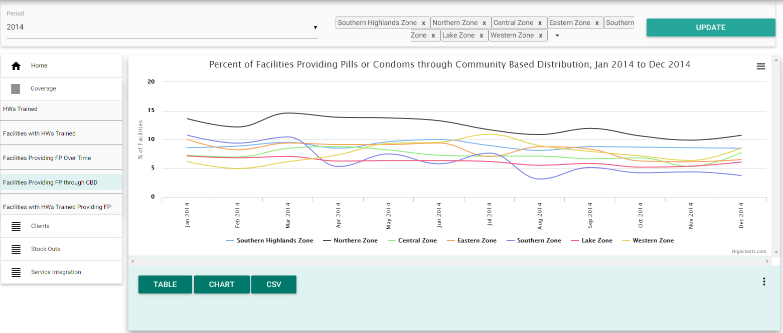

Figure 14: Selecting Facilities Providing FP through CBD

* **Facilities with HWs Trained Providing FP:** This displays three charts to view gaps in providers trained at hospitals, health and dispensaries by method type and geography, month to date. You can scroll the page up and centers, down to view all charts.

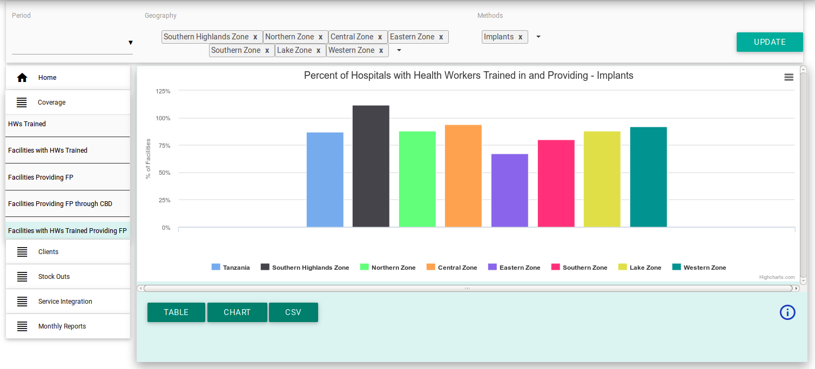

Figure 15: Selecting Facilities with HWs Trained Providing FP, First chart



Figure 16: Selecting Facilities with HWs Trained Providing FP, Second chart

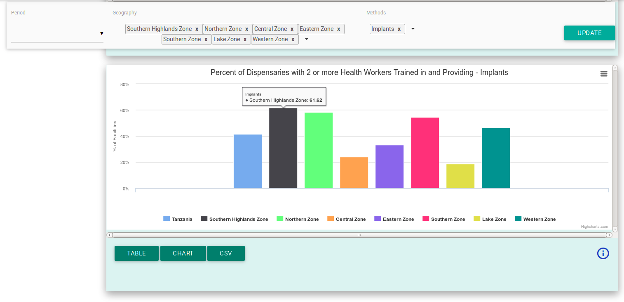

Figure 17: Selecting Facilities with HWs Trained Providing FP, Third chart

#### Client Charts

If you are interested in viewing information on FP clients, click on the ‘Clients’ button and then, depending of your information need, you can select to display any of the four clients charts by clicking on the respective sub-tabs in the clients tab menu.

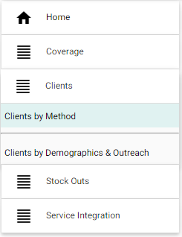

Figure 18: Selecting family planning clients

* **Clients by Method:** This displays two charts. You can scroll the page up and down to view all charts.

1. The first chart displays the number of routine, facility-based clients by method and geography for the most recent month for which data is available.

*Note*: This chart shows ‘new’ versus ‘returning’ clients for the short acting methods (oral pills, male condoms, female condoms and injectables) but for the long-acting and permanent methods it displays total number of clients only.

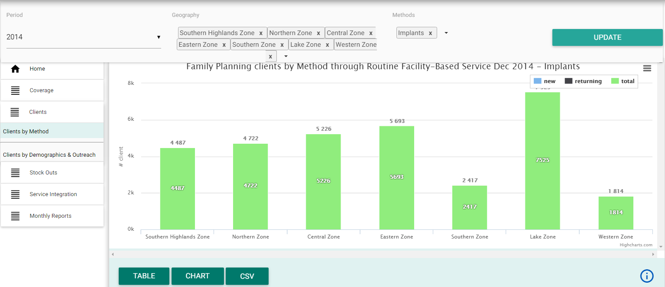

Figure 19: Selecting Clients by Method, Fist Chart

1. The second chart displays the total number of routine, facility-based clients by FP method, in the selected geography, over time.

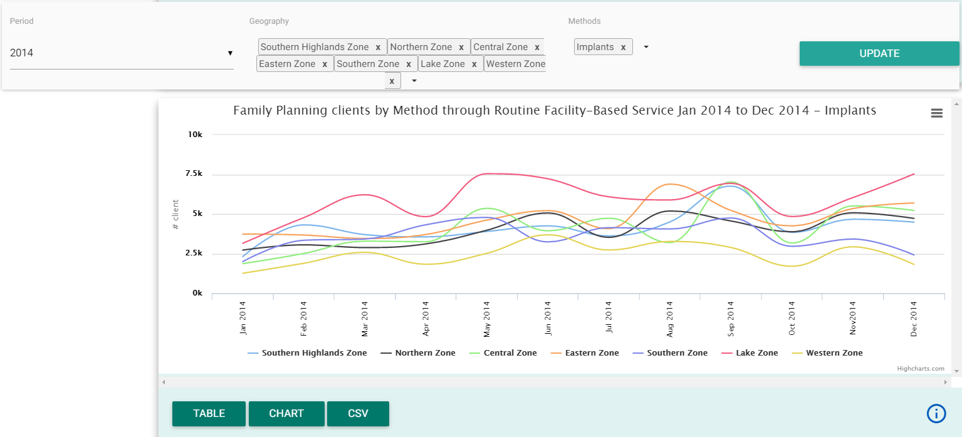

Figure 20: Selecting Clients by Method, Second Chart

* **Clients by Demographics & Outreach:** This displays two charts. You can scroll the page up and down to view all charts.

1. The first chart allows you to view total number of FP clients aged below 20, by FP method in the selected geography, over time.

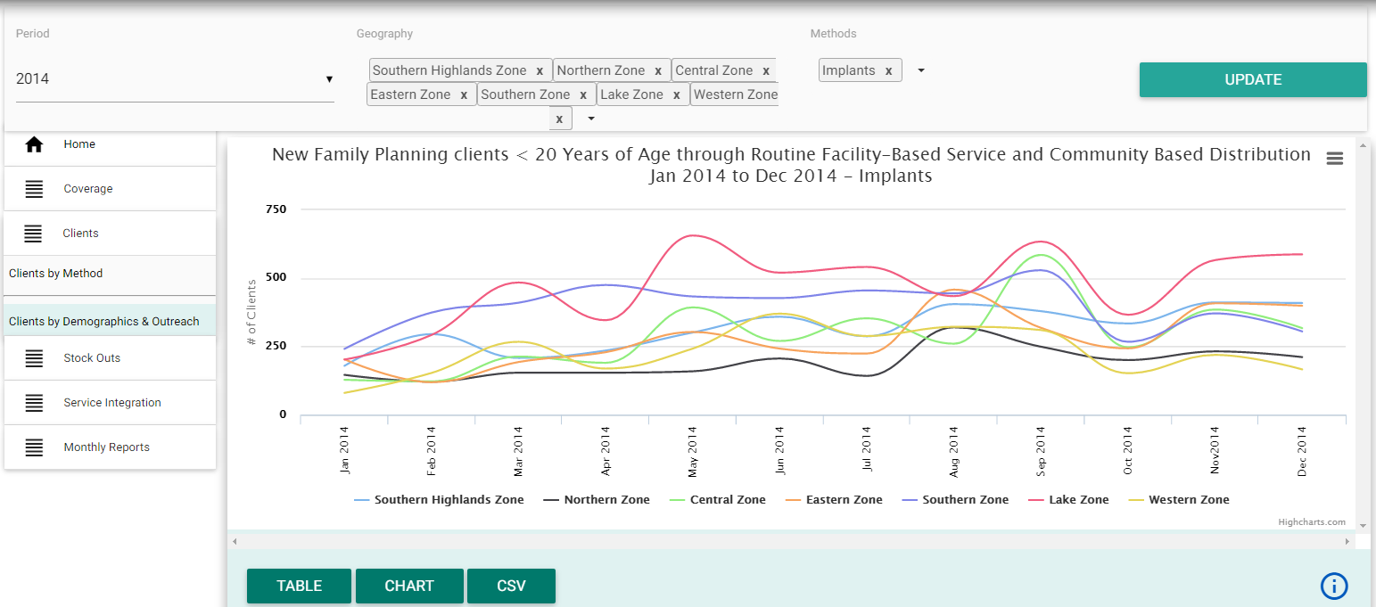

Figure 21: Selecting Clients by Demographics & Outreach, First Chart

1. The second chart allows you to view the total number of FP clients for long-acting (IUCDs or Implants) and/or permanent (Mini-lap or NSV) methods, broken down by clients reached through outreach versus routine/facility-based service provision, in the selected geography, over time.

*Note*: If you select a short-acting method here, no graph will display as these are not offered in outreach services.

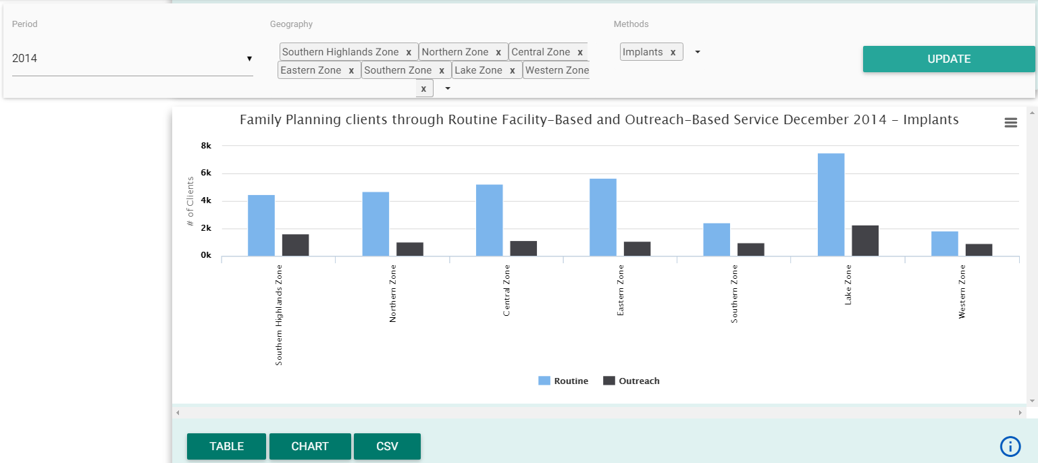

Figure 22: Selecting Clients by Demographics & Outreach, Second Chart

#### Stock-Outs Charts

If you are interested in information on stock-out of FP commodities, click on the ‘Stock Outs’ button and then, depending of your information need, you can select to display any of the two stock-out charts by clicking on the respective sub-tabs in the stock-out menu.

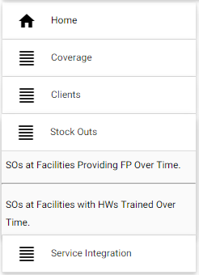

Figure 23: Selecting family planning stock outs

* **SOs at Facilities Providing FP Over Time:** This displays one chart which shows the percentage of facilities that experienced a stock out of pills or injectable, in the selected geography, over the previous 12 months.

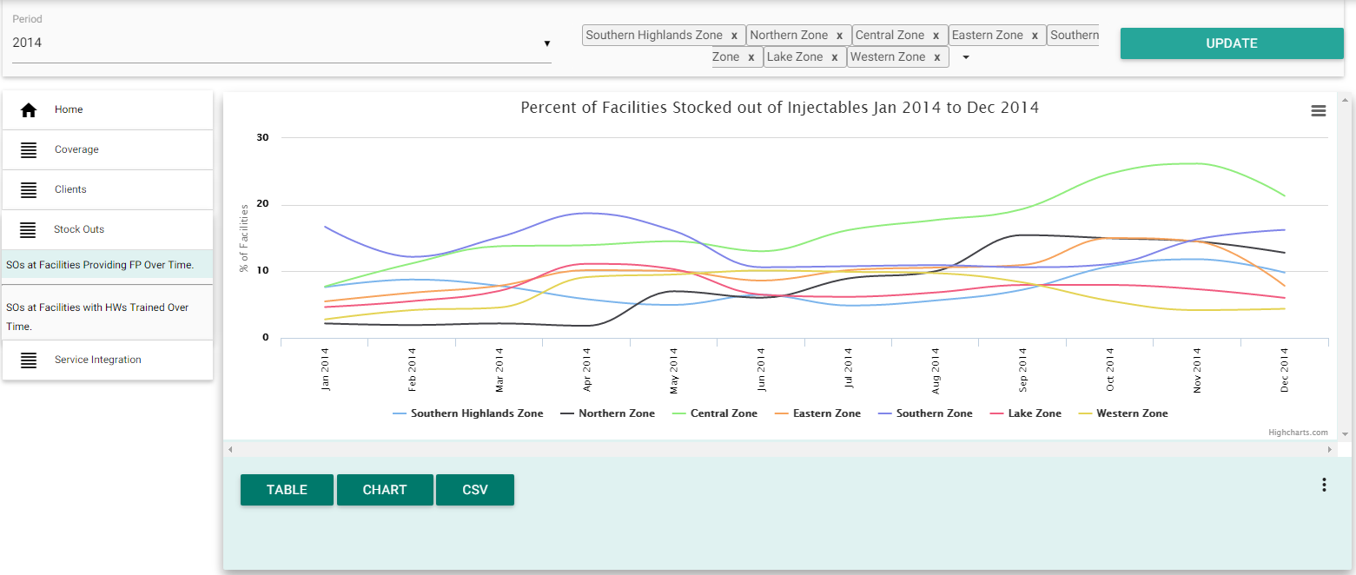

Figure 24: Selecting SOs at Facilities Providing FP Over Time

* **SOs at Facilities with HWs Trained over Time**: This tab displays one chart which shows the percentage of facilities **with a trained provider in short-acting methods**, that experienced a stock out of pills or injectable, in the selected geography, over the previous 12 months.

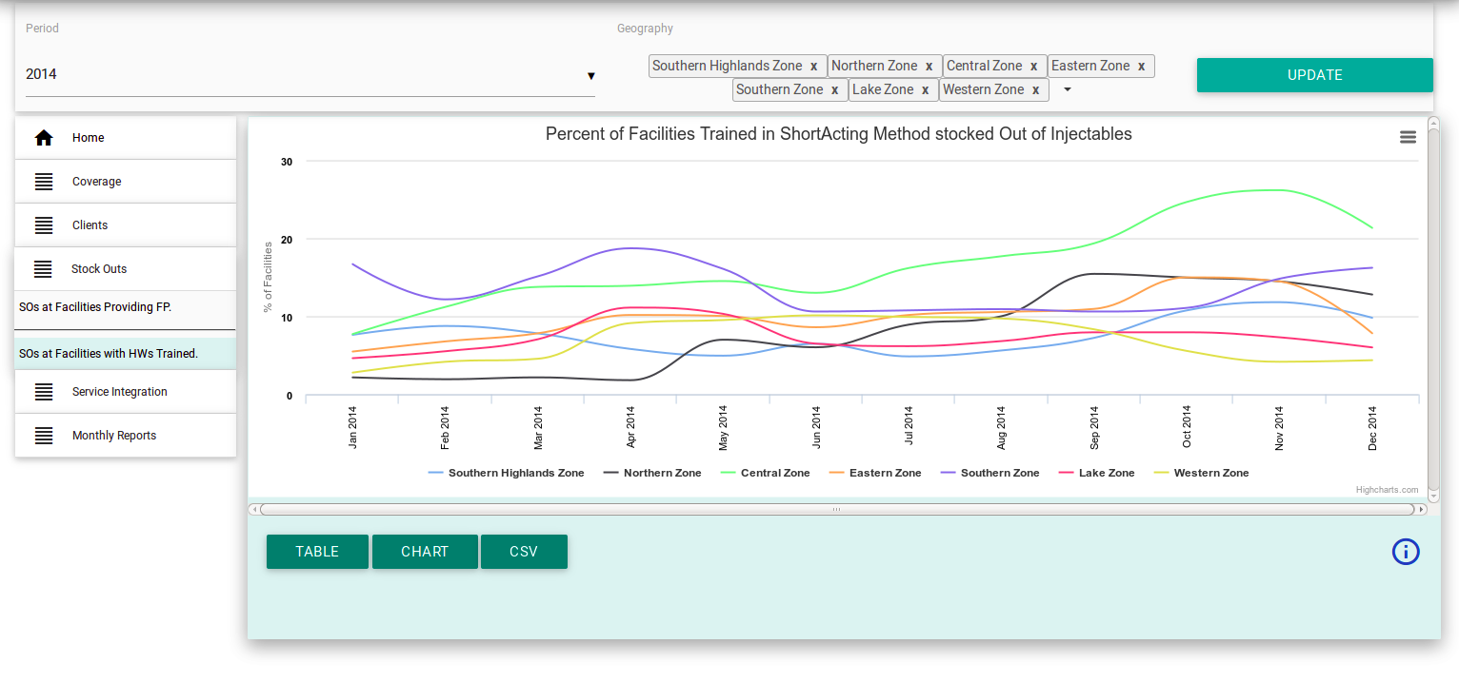

Figure 25: Selecting SOs with HWs Trained Over Time

#### Service Integration Charts

If you are interested in information on integration of FP services with post abortion care (PAC), post-partum and/or HIV testing and counseling services, click on the ‘Service Integration’ tab and sub-tab in the menu.

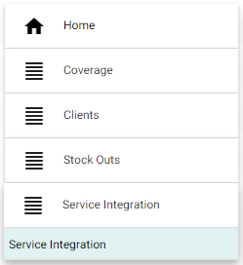

Figure 26: Selecting family planning service integration

This tab displays three charts. You can scroll the page up and down to view all charts.

1. The first chart allows you to view the percentage of clients who adopted FP methods after miscarriage or abortion, in the selected geography, over time.

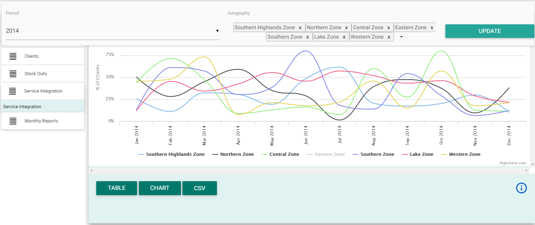

Figure 27: Selecting Service Integration, First Chart

1. The second chart allows you to view number of clients adopting FP within 42 days of delivery, in the selected geography, over time.

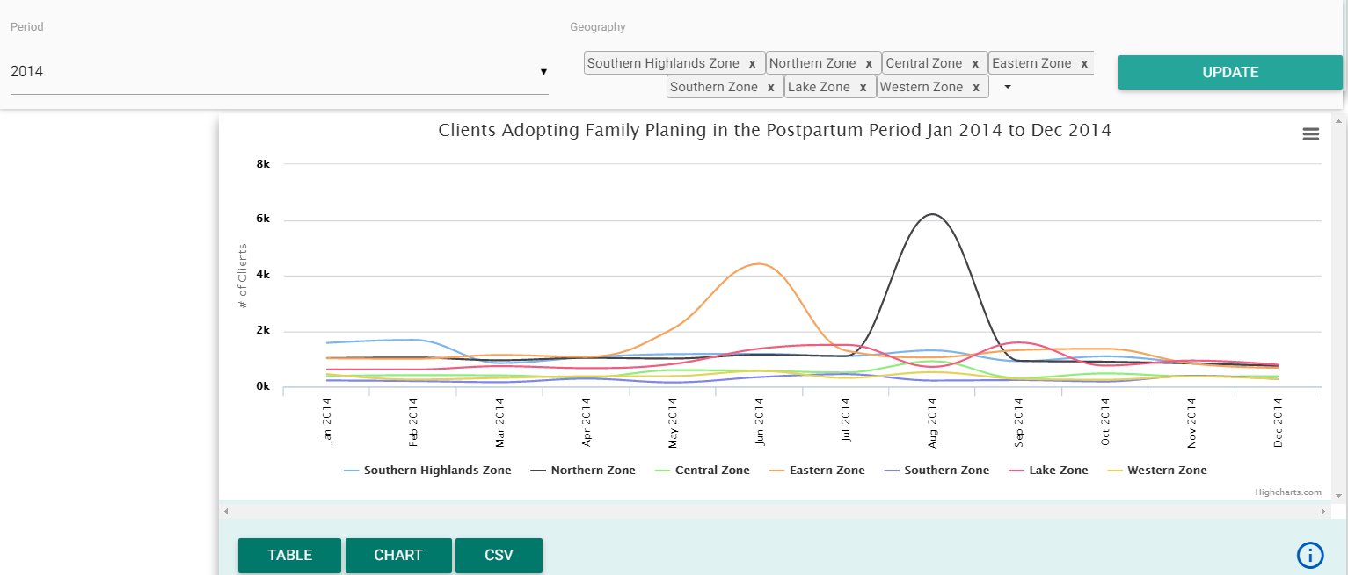

Figure 28: Selecting Service Integration, Second Chart

1. The third chart allows you to view proportion of HIV negative/status unknown FP clients adopting HTC, in the selected geography, over time.

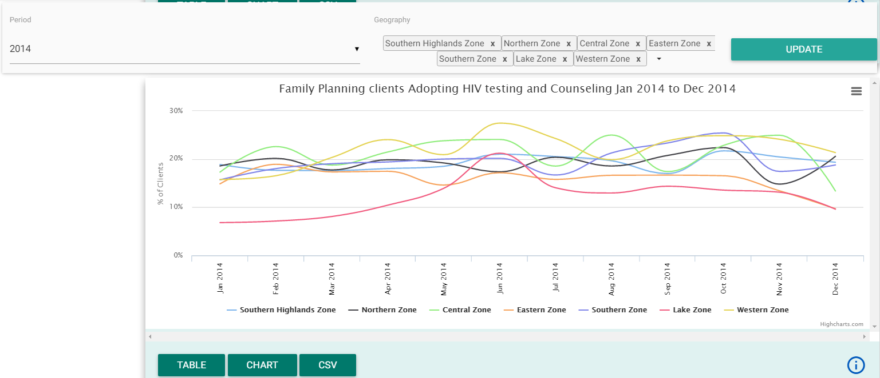

Figure 29: Selecting Service Integration, Third Chart

#### Report Subscription tab

If you are interested in receiving monthly PDF report through your email click on the ‘Monthly Reports’ menu and follow this steps:

1. Enter your name
2. Enter your email address
3. Select report area(s).

* Click on the ‘select organization unit’ field or down arrow or the ‘+’ sign to expand the tree then click on the respective region, district council or Tanzania to select.
* Tanzania or each region or council is added in the list when you click on it. To remove it from the selection, click on the ‘X’ icon after the name in the list.

***Note:*** You can select any number of reporting area i.e. district(s), region(s) and-or national and you will be receiving an email of the monthly PDF report for each report area.

1. After completing step 1 to 3 a subscribe button will appear, click on ‘Subscribe’ and you will be receiving monthly report of the selected report area(s).

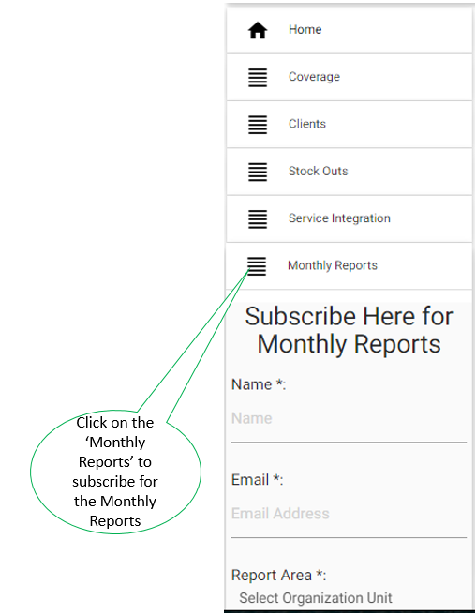

Figure 25: Subscribing for Monthly Reports

## Chart Features

Each of the charts displayed on the FP dashboard has extra features to help you get the most out of the information presented.

1. You can switch between viewing the data as a chart, a data table and an excel file (CSV file)
2. You can get a description of the information presented on the chart and how it was calculated
3. You can download an image of the chart either for printing or for pasting into reports or presentations
4. You can quickly hide or unhide some data presented on the chart without using the selection menus

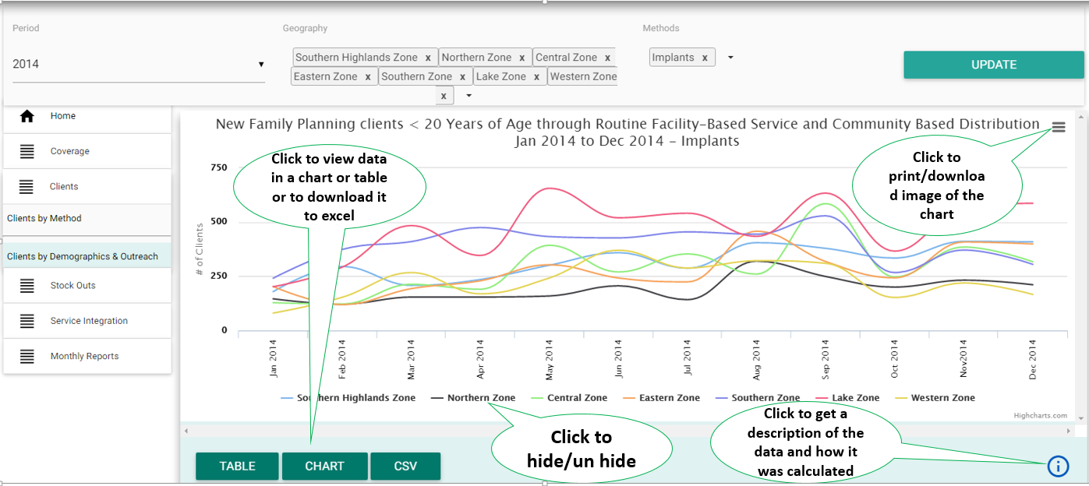

Figure 26: Chart Features

### View as chart or table

* You will notice that seeing the data as a chart is the default presentation of the information selected in the FP dashboard.
* There can be one to three charts on each page. You may need to scroll the page up and down to view all charts.
* If you wish to see the numbers, you can click on the ‘TABLE’ button at the bottom left of the chart
* You can click on the ‘CHART’ button to switch back to viewing the information in a chart.

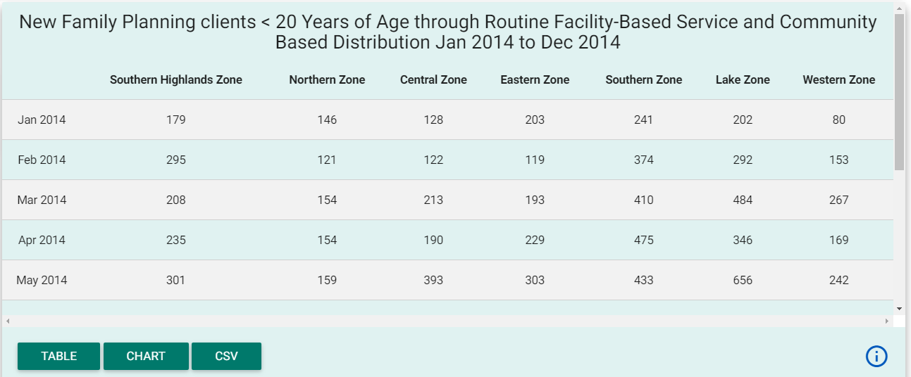

Figure 27: Client by Demographics & Outreach Information Viewed as Table

### Download data as CSV

* You can also download the information presented in each chart of table as CSV format and manipulate the data using other spread sheet applications such as Excel
* Select the CSV menu, the third menu at the bottom left of a particular chart, to download data as CSV

### Print or download the chart

* Select the menu at the top right of the particular chart to print of download the chart.
  + If you want to print the chart select print from the list, select printer and then print (the steps depend on the internet browser).
  + Select Download PNG image, Download JPEG image, Download PDF document or Download SVG vector image to download the chart into the respective format according to your needs

### Get description of the chart or table

* Select the menu at the bottom right of the particular chart or table to get description of the information presented in the chart or table, how it can be interpreted, how it was calculated and the data source
* Click on the ‘X’ icon at the top right of the description screen to close it and return to the chart or table.

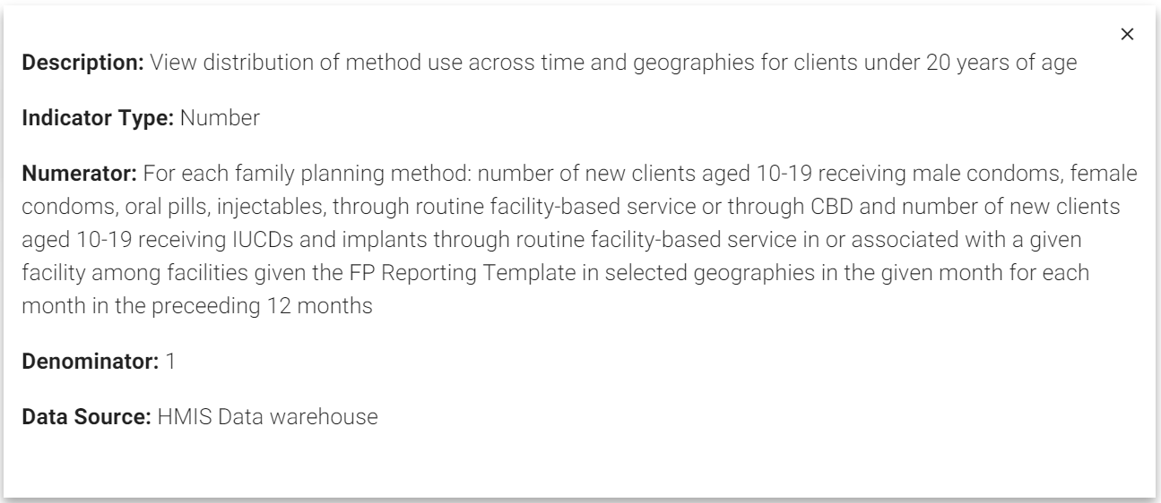

Figure 28: Description of One of the Chart for Client by Demographics & Outreach

### Hide and unhide data

* To quickly hide or unhide data, you can click on the series at the bottom of the chart to hide it from the current chart. If you click on it, the data will be removed from the chart and the legend for the ‘hidden’ will be ‘greyed out’
* To view hidden data again (unhide it), you can click on it again and it will re-appear

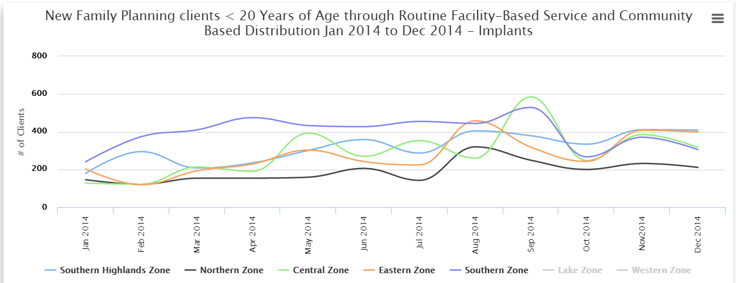

Figure 29: Client by Demographics & Outreach Chart with Lake and Western Zone “Hidden”

### View data label on the chart

If you want to view a value of data presented at a particular point of a line or bar on the chart, hover on the chart line or bar of your interest and the value of data presented at that particular point or bar of the chart will appear as a label.

## PDF Reports

The FP Dashboard also sends monthly PDF reports to Reproductive and Child Health Coordinators (RCHCos) and other subscribing users, summarizing key FP information at national, regional and district levels.

If you want to receive the monthly PDF reports you must subscribe through the ‘Monthly Reports’ button on the left side menu by following the steps described in section 2.3.2.6 of this user manual.

# Appendices

## Appendix 1: Overview of Home Page

Rosie to add table here

3**.2 Appendix 2: Overview of Coverage Charts**

Rosie to add table here

## Appendix 2: Overview of Client Charts

Rosie to add table here

## Appendix 3: Overview of Stock-Out Charts

Rosie to add table here

## Appendix 4: Overview of Service Integration Charts

Rosie to add table here

1. CHAI is a global health organization committed to strengthening integrated health systems in the developing world and expanding access to care and treatment for HIV/AIDS, malaria and tuberculosis. CHAI’s solution-oriented approach focuses on improving market dynamics for medicines and diagnostics; lowering prices for treatment; accelerating access to life-saving technologies; and helping governments build the capacity required for high-quality care and treatment programs.
2.